Stocks and flows

1. Stocks are static variables and flows are dynamic variables.
   * Land:
   * Labor:
   * Capital:
   * Entrepreneurship:

What, How, For Whom?

1. What -> Consumers are king: **what** is produced is determined by the consumer.
2. How -> Resource market: is the **how.**
3. Whom -> Labor market: is the **whom**.

Specialization:

1. Two components of the specialization:
   * Economic agent
   * Firms

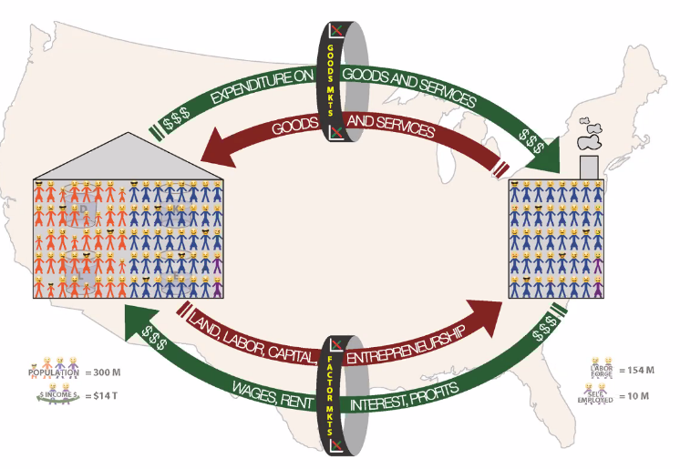The free market:

1. The resources in the economy reside with the individual. Even corporations.
2. Good markets: Walmart is supplying the market and people are demanding (micro).
3. Factor markets: Walmart demands labor and people offer their labor.
4. Example: Soda was made of several resources, which can be mapped by income made by somebody else.

Enter the government:

1. 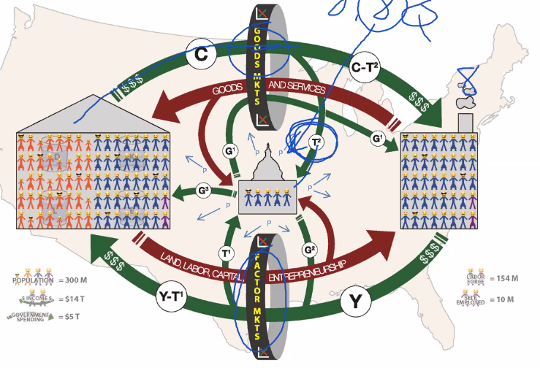We need a government; we need a limited government; it is when government gets too big when the problem starts.
2. Government demands public goods: not everything government demands are public goods, public goods are non-excludable (hard for people not to pay, taxes) and non-rival.
3. Government takes a part to divert and maintain itself.
4. Government makes some Robin Hood spending, example: take from the healthy and give to the sick, take from the employed and give to the unemployed, taking from one person by tax by force and giving that which was taken and give it to another person. The government takes an income tax and takes a sales tax, then the government does some government stuff.
5. Interesting: Guatemala, Chile and Panama are in the top quartile of economic freedom, South America usually demand a more authoritarian approach.

Enter the rest of the world:

1. How money is leaving and entering the country,
2. Foreign exchange is necessary for exchange in currency.

What is economic freedom?

1. When the property they acquire without force, fraud or theft is protected from physical invasion by others and they are free to use, exchange, or give their property as long as their actions do not violate the identical rights of others. (Do what you want but do not hurt other people).

**The five areas of EFW index:** the higher the index the freer the country. Each one of the categories of interest are measured and then the average is taken and that is the index. The overall number for each country is the average of the indexes of interest.

1. Size of government:
   * If we add the informal economy the score gets even better maybe.
2. Legal system and protection of property rights
3. Access to sound money
   * High or low inflation.
4. Freedom to trade internationally
5. Regulation of capital, labor, and business
   * This is a little blurry, things such as the restriction on “hired workers can’t be fired”.

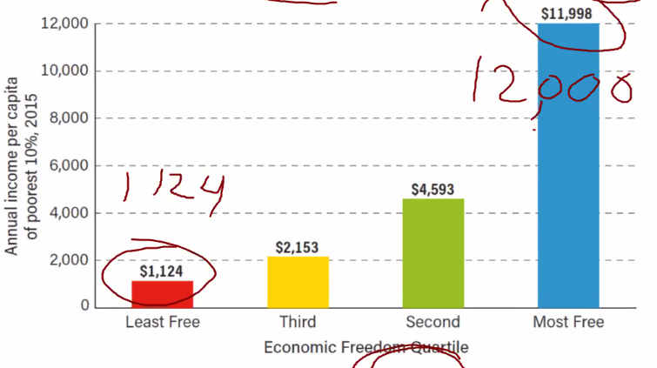**Lessons from the EFW project:**

* Income inequality has been reduced.
* Guatemala is bringing down the average of the top 25% countries of high economic freedom.
* Economic growth: when the bow increases it is radius.
* The poor in the least free countries are 12 times worse off.
* Countries with the least economic freedom have reported dying of starvation during the COVID-19 crisis.
* Life expectancy is about 20 years longer in countries with the most economic freedom.
* Females in freer countries have better opportunities.
* Happiness, self-reported happiness, more money can make you happier.
* Smaller ‘Size of government’ than all average quartiles.
  + The more Robin Hood spending the less economic freedom.
  + Do not give more money to the wrong people.
* Robin Hood spending affects charitable organizations, the more spending the less charitable organizations do in a society.
* Guatemala has a level of bribes that is very high.
* Guatemalan corruption impacts more than you think.
* There can be a minimum wage that is not harmful. There are lots of factors that come in to play.
* Possibly politically lowering the minimum wage can be proposed as: lowering the minimum wage but increasing some other Robin Hood spending.
* Video: Hans Roslin’s 200 Countries.

**Video:**

**For an individual:**

* [Sources of funds] = [Uses of funds]

**Sources:**

1. Productive Labor wages
2. Gifts: transfer from the government, inheritance, etc.
3. Borrowing
4. Selling an asset

**Uses:**

1. Buying new goods and services
2. Give it out
3. Loan it out
4. Buying existing (used) assets

**From a macro perspective:**

* Giving it out and Gifts are canceled out.
* Loan it now and Borrowing cancels out.
* Buying existing (used) assets and selling assets are canceled out.
* From a macro perspective adding up every paycheck is exactly equal to the goods and services produced.

**For a macroeconomy:**

* [Income] = [Spending on new Goods & Services]
  + Note not true for any one individual.
* Gross Domestic Product or GDP:
  + Def: Dollar value of all final goods and services produced within a nation’s boundaries over the year (or some time period).
  + GDP looks at finished goods.
  + Dollar value: we add dollar value because we do not want to add apples and oranges.
  + This is a flow variable, because this variable does not have any meaning unless a time frame us associated with it.
  + * This can be shown to equal national income.
  + Is it appropriate to measure the national welfare using this statistic?
    - The higher the GDP the better of.
    - Some of the individuals are not necessarily better, but as a society we are better.
* Gross National Product:
  + iPhone hechos en China no se parte del PIB es parte del PNB.
* What is wrong with measuring societies wealthy welfare (well-being, happiness) with GDP:
* Things are left out:
  + **Non-Market activity**: things such as mowing your lawn is not accounted for in GDP.
  + Housework, mowing, shoveling.
  + Charity, volunteering:
  + * Because all these things do make the nation better, but they are not measurable in GDP.
* Illegal activity:
  + Drug dealers and criminals also do
  + In Colorado drug legalization made GDP higher, Colorado is happier, is the fact that is going up make it so that everybody is better off?
    - Did making it legal made it better? Taxes are collected on these drugs now (philosophical question)
* Does not measure intangible well:
  + The oil spill increased GDP despite some terrible thing happened. GDP is counter intuitive.
* There is a lag on measuring GDP:
  + There will be a lag in the measurement because the period has to be over for the GDP to be known.

**Comentarios:**

* Las paradojas del PIB: contratar a alguien o generar trabajo siempre van a aumentar el PIB, pero esto no siempre será mejor, pagarle un salario a alguien para que mueva piedras no es productivo pero si aumenta el PIB.
* El PIB nominal y el PIB

**Two approaches for measuring GDP :**

1. **The expenditure approach:** 
   * Def: Sum up all of the spending from four types. These are all flow variables.
   1. **Consumption (C):** Spending by house holds on final goods & services.
      * Biggest category, It’s roughly 70% of GDP. Blurry.
   2. **Investment (S):**  Purchases of new capital (equipment, machines), by business and purchases of new homes by households.
      * Blurry, if Ford buys a tire means that the tire is material and not final.
      * If it is an intermediate good, we are double counting, we need to make sure that it is a final good not only an intermediate good.
      * If a car is sold 5 times, we must avoid counting that car in GDP 5 times.
      * Companies have an incentive for depreciating capital for tax advantage.
      * If it’s a car we classify it as consumption, a home however we’ll treat as an investment.
   3. **Government spending (G):**  spending by government.
      * Instead of a business doing it the government does it.
   4. **Net exports:** (exports are products sold to other countries) (net is exports after tax), net exports x is equal to exports – imports

***GDP equation: GDP or abbreviated as Y, denotes income:***

**Comentarios:** La producción de todo va a ser igual a nuestro ingreso.

1. **Pending**

**Macroeconomic goals, framework and policies**

|  |  |  |
| --- | --- | --- |
| **Goals:** Every president should have these three things in mind.   1. **Economic growth:** Production possibilities frontier. 2. **Low unemployment:** everybody has a job. 3. **Low and stable inflation:** decision maker can plan for the future; they can make long term planning horizon | **Frmamework:**   1. **Aggregate demand / Aggregate supply** | **Policy tools:**   1. **Monetary policy:** intervention from the central bancs and government policy can affect macroeconomic goals. In Guatemala there is an independence between central bank and the government. It only deals with the supply of money. 2. **Fiscal policy:** anything that is not the supply of money is a fiscal policy, example: the government raises the minimum wage and then creates a 80% safety net. |

* **FRED economic research:** page for seeing stats on GDP, birthrate and remittance rate.

**GDP:**

**If, prices on GDP double the GDP doubles, this doesn’t increase happiness, in fact it reduces the purchasing power of the individual.**

**RGDP: Real GDP: with base year in 2014**

In the real GDP we are measuring the change in quantity, we fix the prices to an earlier year. Real GDP reflects changes in quantities of goods & services.

**Example:**

|  |  |  |  |  |  |
| --- | --- | --- | --- | --- | --- |
| **Year** |  |  |  |  | **NGDP ()** |
| 1 | 7 | 25 | 8 | 20 | 335 |
| 2 | 9 | 20 | 9 | 25 | 405 |
| 3 | 11 | 30 | 9 | 20 | 510 |
| 4 | 11 | 35 | 10 | 20 | 585 |
| 5 | 13 | 32 | 11 | 25 | 691 |

**Using the base year of three:**

|  |  |  |  |  |  |
| --- | --- | --- | --- | --- | --- |
| **Year=3** |  |  |  |  | **RGDP ()** |
| 1 | 11 | 25 | 9 | 20 | 455 |
| 2 | 11 | 20 | 9 | 25 | 495 |
| 3 | 11 | 30 | 9 | 20 | 510 |
| 4 | 11 | 35 | 9 | 20 | 565 |
| 5 | 11 | 32 | 9 | 25 | 577 |

**GDP Deflator:**

**Inflation rate ():** =3.5%

**GDP per capita:**